Image | 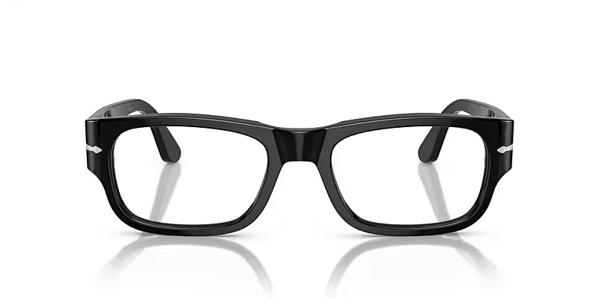
Brand | DIOR
Model Name
Price
PRODUCT DETAILS

